Certificate in Strategic Foresight
Change
P Bishop, Jan 2011

The world is changing at an apparently dizzying pace. The 20th century produced upheavals that changed all our lives--changes in population, technology, the economy, the environment, governance, social values--all on a global scale. These changes tore down traditions, shifted world-views, promoted a truly global economy, created the Internet, established world-wide media influence, and changed fashion, lifestyles, parenting, politics, crime, climate, and an untold number of other things. And that was just the 20th century. The 21st century has already brought us more astounding changes--the attacks on the World Trade Center, ubiquitous hand-held wireless communication and computing, the greatest recession in 80 years and novel biological forms and treatments.

Each of these changes comes with weighty practical and ethical implications. For instance, British scientists have just created artificial sperm from human embryonic stem cells. Will babies now be born artificially? Will long-deceased fathers fertilize their widows? Will science make men unnecessary? Faced with this level of change, it is no wonder that people are asking themselves how they should deal with change? How will it impact their life, their business, their relationships, and their future?

Some questions we might ask:
- What is change?
- How much change is there?
- How do we recognize change, experience it? How does it affect us?
- How does change work? Where does change come from? How do we know what changes are ahead and how do we influences those changes for our benefit?
- Are we taught about change? Why should we learn about it?
- What role does change have in studying the future?
- Can we do anything about change? Do we have a role in creating change or are we powerless in the face of these enormous forces?
- What are some theories of change used in future studies?
- How do you teach about change when teaching about future studies?

In order to answer these questions, we must first understand some of the fundamentals about change.

What is Change?
The Merriam-Webster 2009 online dictionary says that change means
- to make different in some particular way : alter <never bothered to change the will>
- to make radically different : transform <can't change human nature>
- to give a different position, course, or direction to
The very fact that the word can be found in seconds without even opening a book or going to the library is an example of change in our time. Even having a printed dictionary (1604), or having any useful printing at all (1450 in Europe), or writing in the first place (4th millennium BC) also represent profound changes over longer periods of time. Each of these events is a change according to the dictionary, but they differ in scope and timing. These are some of the characteristics of change that we explore in this chapter.

How much change is there?
We have heard the expression, “X has changed everything.” It’s a common feeling, but is it ever true? Actually no. Big changes do change a lot. Losing a job or a loved one, a serious injury, being promoted, moving to another country, winning the lottery—these are all significant changes in a person’s life, but did everything change as a result? Of course not. The people affected by these changes are still who they are. Though they are different, much remains the same. Tennyson described it this way in his poem Ulysses –
Tho' much is taken, much abides; and tho'
We are not now that strength which in old days
Moved earth and heaven, that which we are, we are.

And the same can be said about organizations and even whole societies. New presidents, for instance, can produce profound change in their governments and countries, but even they cannot change everything. The people in the government or the country are still the same, and many of the characteristics of the organization or country will outlast even the most powerful presidents.

Of course, an individual’s death or a group’s dissolution is the ultimate change, but only for that individual or group. Others are affected by the change; but they go on, remaining the same in many ways.

So the first principle of understanding change is to recognize how much is actually changing, that some things remain the same even in the most profound change. That is the difference between change and constants--what is changing and what is staying the same. There is always some of both. We do not want to become so enamored with change that we neglect what is staying the same.

At the same time, we seem bound to focus on change more than on constants, perhaps for very good reason. The mind and even the primary senses automatically respond to change more than to a constant--the movement out of the corner of the eye, the bump in the night, the touch of a loved one. We are wired to pay attention to change.

On a social level, the media uses that tendency to bombard us with what is changing (the “news”) hour by hour or even minute by minute. Most of these changes are fundamentally unimportant or even trivial, but we pay attention to them anyway. By the same token, the media rarely reports the constants, even when they are important--good things like the millions of people who are born, graduate from school, get married each day or deplorable tragedies like persistent malnutrition, disease, poverty and oppression around the world. Once in a while perhaps, when it is somebody important or interesting, but it has to be news, and constants are not news.

So many of those who deal with change, such as professional futurists or those who teach about the future, might have the tendency to over-emphasize change and neglect the constants. We can counter both tendencies by asking the first question – what is changing and what is staying the same? That way we will not ignore the change, but we will not ignore the constants either.

The Five Basic Attributes of Change
The next step in understanding change is cataloguing the various types of change. Early naturalists catalogued the various plants and animals in the meadow and thereby established the fields of biology and ecology as did early astronomers, chemists, anatomists, and even sociologists. Making distinctions is the beginning of making theory so that explaining a phenomenon begins with seeing its different manifestations.

Change occurs along five major dimensions that combine to create many different types or varieties of change. That’s a lot, but the characteristics themselves are fairly straightforward and easy to understand.

Three of those dimensions are continua, meaning that they can take on any value between two extremes. The first dimension, however, is categorical, meaning that the change is either of one type or another. That dimension is where change comes from – its source.

The sources of change – from where?
Change comes from two sources – the world and ourselves. Change from the world is Inbound because it comes at us. Change we produce ourselves is Outbound because it emanates from our actions into the world.

These two sources of change (along with the constants) combine to create our future. Every difference in the future (change) is a combination of what the world does and what we do (or not do) over time. So we cannot control the future because the world has a role, but we are not powerless either because we can influence the outcome as well. That fact gives us some encouragement since we realize that we can actually influence the future. At the same time, it also makes us careful because the world is changing at the same time. Just as it is prudent to look both ways before the crossing the street, so we should watch how the world is changing (inbound) before we act to influence the future (outbound). Both the world’s actions and our own will create the future we experience.

The levels of change – how broad?
The next two dimensions of change relate to space and time—where are the changes taking place (space) and how long does it take (time). The spatial dimension of change is its level. There are three basic levels of change, as depicted in Figure 1, though the distinctions are not nearly as different as the figure might suggest.

Figure 1 – Levels of change
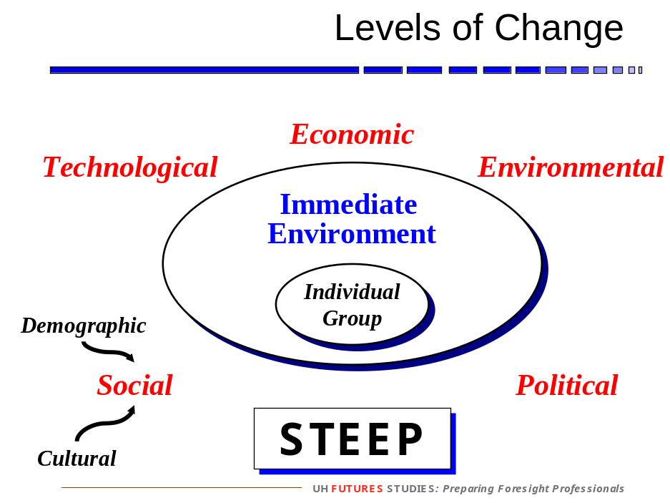

The lowest level of change is what we are most interested in – ourselves! – either as individuals or as groups, such as families, organizations, communities, societies or even the whole of human civilization. Each individual and group lives in an environment consisting of two levels—the immediate environment and the global environment. The immediate environment consists of those individuals, groups or parts of the physical environment that the individual or group interacts with on a regular basis. So for individuals, the immediate environment consists of family and friends, business or school acquaintances, the neighborhood, the job or the school.

The global environment is everything outside the immediate environment. It is also called the STEEP environment because of the acronym derived from five domains in that environment – Social, Technological, Economic, Environmental, and Political. Other common labels are PEST (Political, Economic, Social, and Technological) and EPISTLE (Social, Technological, Economic, Environmental and Political adding Information and Legal). The author uses six domains, dividing the Social domain into the Demographic and Cultural domains, although that do not produce a pronounceable acronym. Too bad!

The different levels in the ocean are a good illustration of the levels of change in society. The surface wind whips up the waves but only on the surface. When the wind stops, the waves stop. Beneath the waves, the tide moves the water against the shore, but the surface wind does not affect the tide much at all. The deep ocean currents circulate huge amounts of water around the world but they move slowly. The surface winds have no impact on the deep currents.

The distinction between the immediate and global environment is not very precise, nor does it have to be. Is the mayor of the town or the police officer in the neighborhood part of the immediate or the global environment? It depends. If the individual or group is involved in city politics, then the mayor would be part of that individual’s immediate environment. Otherwise, probably not. By the same token, a flood in one’s neighborhood is an event in one’s immediate environment, but sea level rise is part of the global environment, unless one’s neighborhood is on the coast.

In fact, where things are exactly is not that important. The important thing is that inbound change comes to use from both environments. Our immediate environment, for sure, such as changes in our family, friends, work, school, etc. But those changes rarely start from scratch. More often, those changes are themselves affected by changes in the global environment. So people get and lose jobs on the basis of the overall economy; they get sick from the air pollution in the city, or they lose a loved one in war or in traffic accidents ultimately because of changes in the global environment (Figure 2).

Figure 2 – Inbound Change

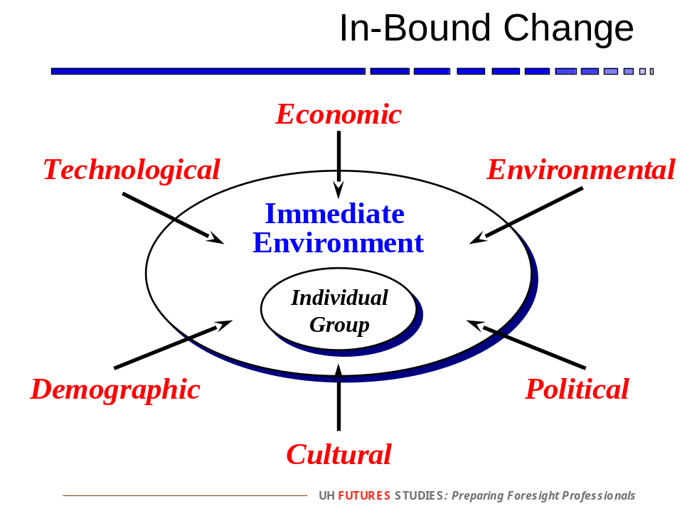

Long before the futures movement became mainstream, the famous sociologist, C. Wright Mills, described the relation between the immediate and the global environment in his book, The Sociological Imagination.
Nowadays people often feel that their private lives are a series of traps. They sense that within their everyday worlds, they cannot overcome their troubles, and in this feeling, they are often quite correct. What ordinary people are directly aware of and what they try to do are bounded by the private orbits in which they live; their visions and their powers are limited to the close-up scenes of job, family, neighborhood; in other milieux, they move vicariously and remain spectators. And the more aware they become, however vaguely, of ambitions and of threats which transcend their immediate locales, the more trapped they seem to feel.
Underlying this sense of being trapped are seemingly impersonal changes in the very structure of continent-wide societies. The facts of contemporary history are also facts about the success and the failure of individual men and women. When a society is industrialized, a peasant becomes a worker; a feudal lord is liquidated or becomes a businessman. When classes rise or fall, a person is employed or unemployed; when the rate of investment goes up or down, a person takes new heart or goes broke. When wars happen, an insurance salesperson becomes a rocket launcher; a store clerk, a radar operator; a wife or husband lives alone; a child grows up without a parent. Neither the life of an individual nor the history of a society can be understood without understanding both.
Yet people do not usually define the troubles they endure in terms of historical change and institutional contradiction. The well-being they enjoy, they do not usually impute to the big ups and downs of the societies in which they live. Seldom aware of the intricate connection between the patterns of their own lives and the course of world history, ordinary people do not usually know what this connection means for the kinds of people they are becoming and for the kinds of history-making in which they might take part. They do not possess the quality of mind essential to grasp the interplay of individuals and society, of biography and history, of self and world. They cannot cope with their personal troubles in such ways as to control the structural transformations that usually lie behind them.
As Mills says, understanding change in the immediate environment requires understanding change in the global environment. We are all part of history, our own history and the history of our times. And just as people in past times were part of a larger tapestry of change, so we are part of that historical tapestry as well. The only difference is that we have a perspective on their world that few of them had. In the study of history, we can abstract from the daily details of their world and see what was going on in a larger sense.

But we are not condemned to remain ignorant of that larger sense in our own time. Even though we cannot have the benefit of the long-term perspective that future generations will have, we do not have to focus only on our immediate environment either. We can connect our world and its future with the larger world. We can see our world as a microcosm of the larger world. And, most importantly, we can see change coming over the horizon, even before it affects us directly. That is the futures perspective, and it comes by paying attention to what is going on in the global environment and imagining how it might affect our immediate environment.

Mills goes on…

What [people] need, and what they feel they need, is a quality of mind that will help them to use information and to develop reason in order to achieve lucid summations of what is going on in the world and of what may be happening within themselves. It is this quality, I am going to contend, that journalists and scholars, artists and publics, scientists and editors are coming to expect of what may be called the sociological imagination…. The first fruit of this imagination - and the first lesson of the social science that embodies it - is the idea that the individual can understand her own experience and gauge her own fate only by locating herself within her period, that she can know her own chances in life only by becoming aware of those of all individuals in her circumstances. In many ways it is a terrible lesson; in many ways a magnificent one.

We are not teaching sociology; we are teaching about the future. But the sociological imagination, as described by Mills, is also the futures perspective. Understanding long-term change requires a broad vision of what is going in the world so we can understand what may happen to us in the future. So futurists focus on the global environment, not because it is more important, but because it is often invisible, to most people at least. Futurists pa attention to the global environment just as everyone else is paying attention to their immediate environment.

Once in a while, however, every individual and group should look past the immediate environment and see what is coming in the global environment. They do not have to be futurists, but they should listen to them and to others who are monitoring change at that level.

And fortunately, we are not powerless in the face of those forces either. We cannot control the future, but we can influence it, most easily in our immediate environment, but in some cases, in the global environment as well.

Figure 3 – Outbound Change

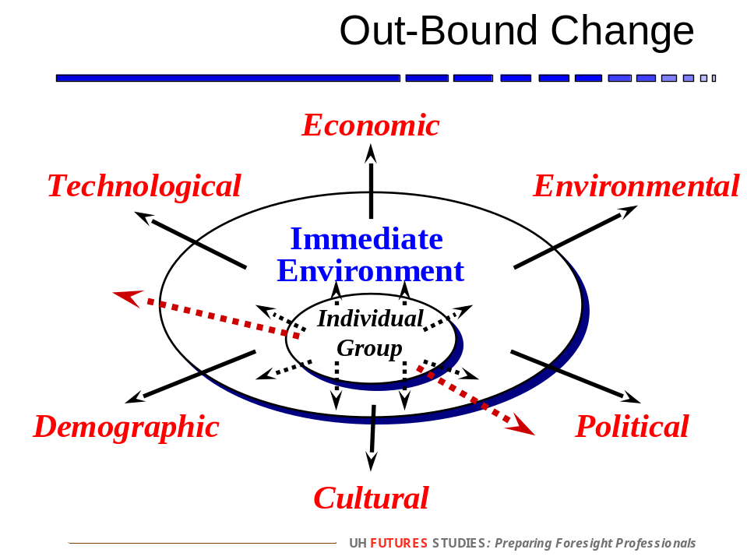

So the arrows don’t all point inwards. Each individual has a sphere of influence in which he or she can influence or even create change. We have influence over our own behavior and often the behavior or others, like children or employees. We can influence or friends and acquaintances. Some people’s sphere may be quite large, even extending into the global environment itself. No matter how large the sphere, it is there, and what we do in that sphere contributes to the changes and the future we experience.

Time horizons – how long?
The physical horizon is the farthest we can see. In a valley, it is quite short; in a meadow or a desert much father, and on top of mountain or in an airplane, farther still. In the same way, the time horizon is that part of the future we choose to focus on. Unlike the physical horizon which is fixed, the time horizon is variable. We can focus on short-, medium- or long-term change.

The time horizon is usually expressed as a number of years, like next year or the next five years, or as an exact year, like 2020 or 2050. That sounds very precise and scientific, but we should not take the numbers too seriously. No one really knows exactly what life will be like in 2020 or 2050 as opposed to 2019 or 2051. Rather those years simply indicate roughly how much change we expect to occur. The more years, the more change we expect to occur and the more differences we expect between the present and the future at the time horizon.

The time horizon also varies with the domain, the area of the future we are focusing on. Climate change, for instance, has a long time horizon; it will take a long time for significant effects to occur. Politics, on the other hand, has very short time horizons; significant changes can take place in a very short period of time. Even though significant change can occur in a very short time, like the fall of the Berlin Wall or the attacks of 9-11, they usually don’t. So constants generally dominate the short-term, and change and difference become more visible the longer into the future we choose to focus.

Futurists tend to focus on longer time horizons than most other professionals. The reason again is that few people are doing that. We focus on the long-term also because change in the global environment takes longer to affect people than change in their immediate environment does. The global environment will not affect most people for a while yet, but it will eventually. It is common therefore for futurists to be talking about 2020 or 2030 these days, 10-20 years into the future.

Some would argue that 10-20 years is too long, that it is a waste of time to think that far into the future. Most strategic plans, for instance, only focus on 3-5 years, even though that is still a stretch for many people. The futurist responds that it is important to anticipate the future that far out because many of the decisions we make today have consequences for that time. Choosing a mate or a major, building a facility or a company, making an investment or buying a home—many of these will be successful or not depending on how the future turns out 10-20 years from now.

Even more importantly, it takes that long for most people to influence the future in any significant way. Most of us have little power to change the global environment; it’s not in our sphere of influence. But exerting what power we do have, over long periods of time, toward a consistent goal produces marvelous results, but only over the long run. Think of those historical figures who accomplished great things in government, or science, or art. In most cases, their greatest achievements came only after decades of work, exerting themselves toward the same goals over all that time. If we aspire to do great things (And who doesn’t at some point in life?), then we must also be patient about how long it will take. Ten-twenty years might be just the beginning!

Rates of change – how fast?
The rate of change, how fast things change, varies across a continuum from continuous, long periods of gradual change, to discontinuous, short periods of intense change. Most change is continuous – getting older, growing the economy, warming the planet, etc. As a result, we are pretty good at anticipating continuous change since we have experience with it and we have time to adapt. We even have pretty good predictions of the future of continuous change if it goes on long enough.

The opposite is true of discontinuous change. It happens rarely so we have little experience dealing with it. It happens so suddenly that we have little time to adapt. And it is generally unpredictable so we never know when or how it will occur. It is the discontinuity, the sudden event and shift that makes the future problematic. If the future were all a continuous path into the future, like a road or a river, it would not be nearly as difficult to deal with.

The past is full of discontinuous changes—
- in technology, the invention of the printing press, the steam engine, the electric light, the transistor, the birth control pill.
- in the economy, the invention of currency, the establishment of the joint stock company, repeated crashes of the stock markets, and more recently the appearance of financial derivatives that led to the recent recession.
- in governance (politics), various wars and revolutions, including the American revolution, the assassination of political leaders, the passage of important legislation, like the Civil Rights Act or Medicare.

In fact, most of the study of history, perhaps even too much of it, is the study of discontinuities—events that have changed the world. Historians are just as fascinated with sudden change as the news media is. It is curious therefore that our overall image of the future, rather than being filled with events, is fundamentally “more of the same”—more people, more computers, more money, more problems. We do not see a future that is populated by discontinuous events, only by continuous changes. Of course, the reason is that we can predict the future of continuous change, not of discontinuous change. For instance, we expect the world’s population to be about 9 to 10 billion people in 2050. Since we cannot predict discontinuous events, we fail to recognize that they will be just as important or even more important than the continuous changes that we can predict. So the paradox remains – We see the past as full of interesting and important events, but we see the future as one long, continuous stretch, generally uninterrupted by events.

As a result, futurists focus on potential future events and generally surprising developments since everyone else is focusing on and is relatively comfortable with continuous changes. Not that we want to make people uncomfortable, but someone has to do the work that no one else is doing. So futurists do not know what discontinuous events lie in the future any more than anyone else does, but they guarantee that they are out there. So the futurist acts like the sailor--aware that there might be rocks or reefs under the water, unseen yet there nevertheless.

And the discomfort with not knowing when and how discontinuous events will occur is manageable once we are aware of the changes and their consequences going on the immediate and global environments. While we still cannot predict discontinuities, we can imagine possible changes all the time, getting comfortable with the idea of change even though we cannot predict which ones will actually occur. What is more, people who aspire to do something great actually look forward to discontinuous change because it shakes up the system and frees up resources for change.

So in sum, futurists are focusing on those aspects of change which most of the rest of society does not – the global environment, the long-term horizon, and the potential discontinuous changes. Not that that focus is better than the immediate, short-term and continuous changes that others are familiar with. Futurists are not opposed to knowing about those changes as well. Far from it. Rather they are working in parallel with other professionals who deal with the future, focusing on the aspects of change that they are not.

The forms of change – which shape?
The last dimension of change relates to how that change occurs over time, often depicted in the form of a graph. We focus on four graphs of continuous change and one of discontinuous change.

Linear
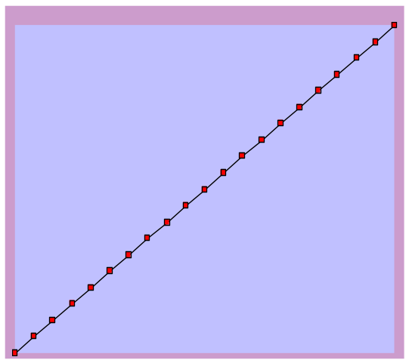

Linear

The first shape is the most common since we all study it in algebra and in statistics. It is the famous equation y = mx + b, perhaps with some different other variables and parameters but in the same form. When graphed, linear change forms a line, hence the term linear. It is the simplest form of change so we teach it all the time. Unfortunately, straight lines never occur in nature or in change over time. Einstein, in fact, showed that even space itself is curved. A well-traveled astronaut, Story Musgrave, once pointed out that when he saw a straight line from space, he always knew that it was man-made—a ship’s wake, an airplane’s contrail, a pipeline or the boundary between two territories.

Linear change is equal amounts of change over equal time periods. We first encountered it in simple interest—making an investment that returned the same amount of money (say $100) each time period (a month). But no one loans or invests money at simple interest, nor does change add or subtract equal amount in equal times in real life.

In fact, thinking linearly can get us into trouble when are trying to create change (outbound). We mistakenly assume that the effect of our effort is proportional to the amount of effort that we put in. (How many times have I heard students who received a lower grade than expected say that they “worked very hard during the course”?) So we expend twice as much effort, we should get twice as much change in return. But it never works out that way. In many cases, we can expend enormous effort and get little or no return; in other cases, even a minor effort can produce a tremendous change, such as when a butterfly in the Amazon can create a hurricane in the Atlantic Ocean. Most change is not proportional to the effort expended, and thinking so can be quite dangerous.

Non-linear – exponential
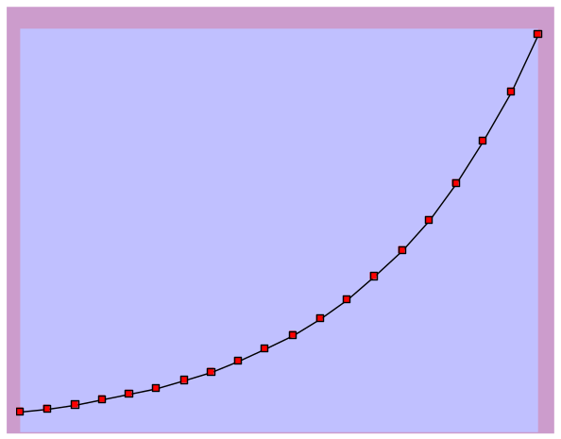
Exponential

People don’t make investment for simple interest, but for compound interest; not equal amounts in equal times, but equal percents in equal times. So we buy a $1,000 Certificate of Deposit at 5% interest (paid annually), and we get $50 at the end of the year. If we reinvest that, we now have $1,050 in the Certificate which returns $52.50 at the end of the second year. And so on. Pretty simple.

The mathematics of exponential growth (compound interest) can mislead us as well. There is the famous story of the Maharaja who was so grateful to the Wise Man that he told the Wise Man to name his price. The Wise Man said that all he wanted was for the Maharaja to place one grain of rice on the first square of a chess board and double it for each square after that. So two on the second, four on the third, eight on the fourth, etc. The Maharaja readily agreed because he thought he was getting off cheap. Actually he went bankrupt because, before he got to the 64th square, he already had to spend all the grains of rice that had ever been grown in the history of human civilization! So beware of exponential growth!

Exponential growth (and decline) is probably the most common form of continuous social change. It describes the growth of populations (both human and non-human), technologies (such as the Internet), economies, political power, etc.. But nothing goes on forever, even exponential growth. Just as the Maharaja could not possiblly pay the price he agreed to, so the planet will never contain the 100 billion people that would result if current growth were to continue for the next 180 years or so. Something will happen to stop or reverse that change before it gets out of control—a discontinuity perhaps. So exponential change goes on for a while, but not forever, and the end often surprises people.

Non-linear – asymptotic
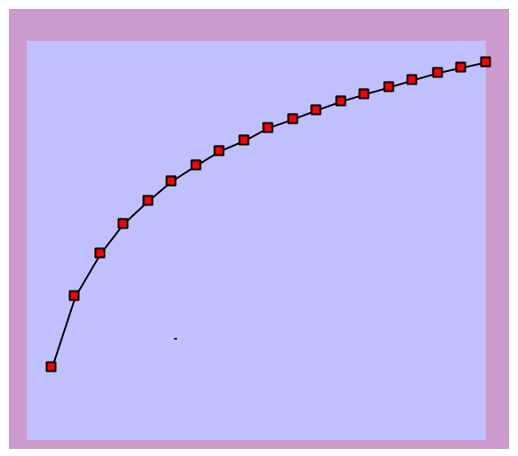

Another common form of change is a change that approaches a limit. World records in sports are an example of asymptotic change, also called logarithmic or the law of diminishing returns. Swimmers break the world record by thousandths of a second. They rarely if ever leap ahead by a whole second. Even though they are much better trained than swimmers were 10 or 20 years ago, they can only swim so fast until they approach the limit of human capacity. They can spend years getting ready for the Olympics, and they are grateful if they shave a half-second off their time. Large input; small output—non-linear change.

As with the others forms, the law of diminishing returns can also fool people. Take a sales meeting in which the sales of a product is increasing, but the rate of increase is decreasing – classic asymptotic change. One side who looks at the absolute increase judges that the product is doing fine; the other side who looks at the relative decrease believes that the product is nearing the end of its life cycle. Both are correct. They are just using different measures to judge the health of the product.

Non-linear – cyclic
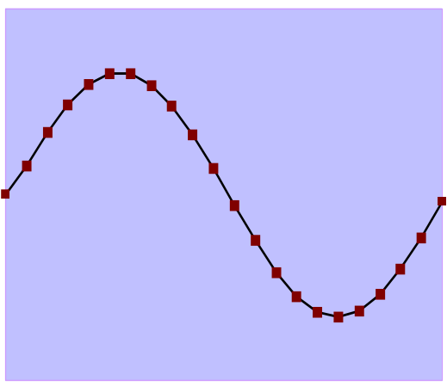
Cyclicc

The last type of non-linear continuous change that we will consider is cyclic change. Cyclic changes oscillates between a maximum and minimum. It is not as regular as the classic sine wave depicted here, but it does increase for a while, then decrease, then increase, over and over again. As with the others, cyclic change can be deceptive because for short periods of time they look like a trend, increasing or decreasing. Then people are surprised when it reverses. They expected it to continue in that same direction.

Political power tends to behave in a cyclic fashion. One political persuasion or party (liberal or conservative, for instance) gains support and power, but after a while, it loses favor and the other party gains power. The tendency for companies to centralize and decentralize seems to follow a cyclic pattern as well.

Discontinuous – S-Curve
All the curves above continuous change. We have a special curve for discontinuous change called an S-curve. S-curves are not covered in ordinary math or stat classes even though they are a common and useful way of describing change

Figure 5 – S-Curve

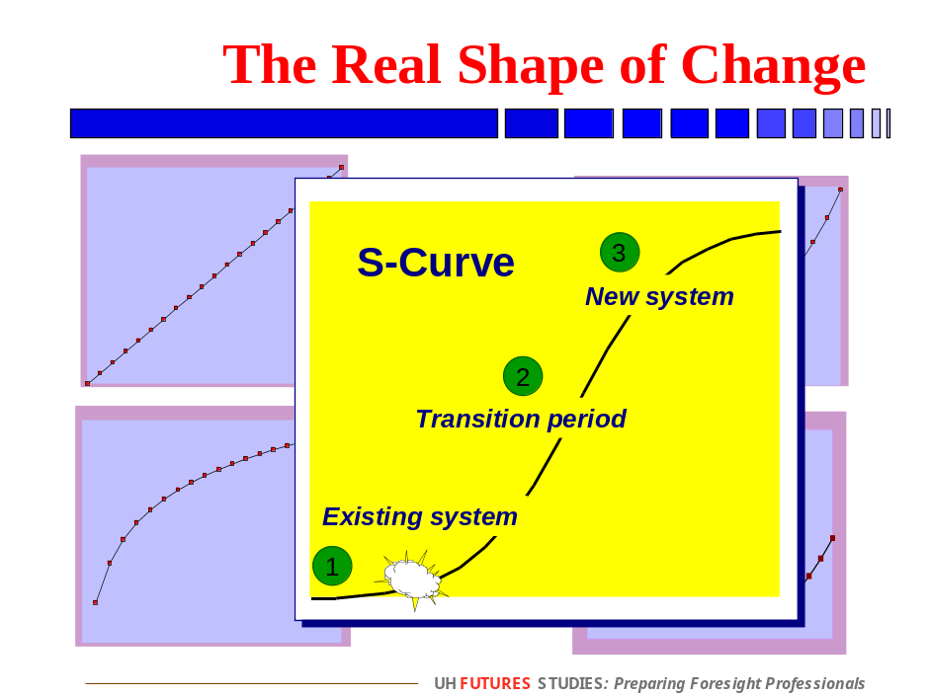

The S-curve (called that because it looks like an elongated S) has three distinct phases –
- The old system that most people expect to continue (along the bottom of the graph)
- The transition period that follows a discontinuous event (the little explosion)
- The new system that eventually emerges from the transition (along the top of the graph)

The S-curve actually has two ways to fool people. The first is that people expect the existing system to go for a long time, if not forever. They do not realize that the system has the potential for tremendous change rather quickly following a discontinuous event. The second way is that, once in the transition period, people expect that to go on longer as well. So in the 1950s we thought we would have flying cars, an extension of the growth of the automobile and the airplane. In the 1970s, some oil companies thought that the price of oil would reach $100 a barrel, but it barely got above $40. Today some people believe we will download our brains into computers someday. Is that an extension of the transition period too far?

The reason for reviewing these shapes of change is to not be fooled by how things are changing., but the important lessons are –
- There is no linear change so do not use that one.
- Exponential change can speed up unexpectedly, but it also does not go on forever.
- Asymptotic change is still increasing, but the change is actually coming to an end.
- Cyclic change looks like a trend until it reverses.
- And finally and most importantly, discontinuous events begin the transition from one system to another, but that transition does not go on forever either.

A Model of Change -- Punctuated Equilibrium
Most people believe that their lives and the society they find themselves is relatively stable, and they are right. Stuff gets done. And when things get a little out of whack, usually something comes along to put things back on a steady course. So we might have get the car fixed, but that’s what savings are for. Or we experience a little bit higher than expected return on our investments so we buy a new car instead. We just kind of bump along day by day, year by year. That’s the description of equilibrium – some change, but nothing too great, and whatever change does occur tends to die off after a while.

Obviously equilibrium is the product of continuous change and the minor adjustments we have to make to move forward. Once in a while, however, we encounter a discontinuous change, something that really upsets the equilibrium. We lose a job, get sick, or on the positive side, get promoted or get married or have a child. No equilibrium there. This is really different!

So putting continuous and discontinuous change together in a sequence seems to go like this –
- Go along, go along, go along…
- And then, wham!
- And again go along, go along, go along…
- And then again wham!

You get the picture. It’s equilibrium most of the time interrupted (punctuated) by a few sudden changes. And each punctuation changes the equilibrium substantially. We call the equilibrium periods “eras,” a term we borrow from history. Historians will speak about the Napoleonic or the Victorian era. The Renaissance, the Depression and the Cold War were eras as well. Eras are periods of relative stability and coherence, they have a distinct identity, and they always begin and end with a discontinuity. So the era of the Depression, in the United States at least, began with the crash of the stock market in October 1929 and ended with the attack on Pearl Harbor in December 1941. The Cold War began when the Soviets exploded their first nuclear weapon in August 1949 and ended when the Berlin Wall fell in August 1989, exactly 40 years later.

Transitions are troubled periods of confusion and conflict. Few people like the transition period because the familiar is passing and the unknown is approaching. Joseph Schumpeter called these transitions “Waves of Creative Destruction,” where spurts of innovation destroyed established enterprises and yielded new ones. The better descriptive would perhaps be “Waves of Destructive Creativity” because the destruction happens before the creativity

The good news about the transition is that transitions do not last forever. A new equilibrium eventually emerges into a new era. The bad news is that we do not know where we are on the transition curve and therefore how long before the new era emerges. More important than the timing, however, is what the characteristics of the new era will be. How will it be different from the old era?

The answer to that question is not always as easy as it looks. As I write this in the summer of 2009, the transition to mobile computing is underway. The iPhone and the whole bevy of other hand-held, wireless devices is changing the way people communicate. It is clear that almost everyone will have one of these devices in the future. And some of their new uses, such as paying bills and navigating through cities, are already apparent. Other uses are not as clear. For instance, will we get ads every time we pass a store? Will people need to use their devices while driving? Will people be able to steal my identity from this device? Those who get a sense of the characteristics of the new era before others do have an obvious advantage. And that is part of what anticipating change is all about. While we cannot predict the characteristics of the new era with any certainty, we can imagine and prepare for some of them nevertheless.

But the old era does not go away quietly. We are comfortable with the time we were born into because we understand it; when things change we grow uncomfortable. Imagine how a person from the past would feel if they were suddenly thrust into our era--the era of cell phones and email, the threat of global terrorism, of stress, of financial crisis; they would not envy us and would quickly seek refuge back into their own time. Yet also imagine a person of the 21st century trying to live in an age without telephones, automobiles, air travel, penicillin, or the Internet; they would be miserable. Our future children will be happy in world in which they live, even though we would not want to live there ourselves.

And what is more, we have a dilemma, even in our best minds. If everything is not going to change, as we discussed above, what will change and what will not? Which elements of the old era will remain and which will change? Most people’s reaction to the benefits of the new era is, “Yes…but”. Yes, it will be great, but it also means we will have to give up some things that we like to do. Sorting through what remains and what needs to change is one of the most difficulty and tricky parts of navigating the transition from one era to the next.

None other than the great Charles Darwin got the long-term model of change wrong, at least for biological evolution. As brilliant as he was in articulating the theory of natural selection, he assumed that evolutionary change was continuous. In fact, he used Leibniz’s the famous phrase, Natura non facit saltum—Nature does not jump. But when biologists dug up the fossil record from the bottom of the ocean, they found that it did. They found long periods of relative stability among species interspersed with brief periods of significant change. That record led Niles Etheridge and Stephen Jay Gould to coin the term “punctuated equilibrium” in their famous article in 1972. So we are applying that term to changes in society as well.

So granted that punctuated equilibrium is the correct model of long-term change, why are there punctuations in the first place? Why is all change not continuous, getting better all the time, as Darwin thought? The reason is that over time the era becomes mature and the continuous change in that era slows down (asymptotic change). Change in the new era takes time to get going, to get things right. But once right, they tend to level off into relatively modest continuous change. The era becomes subject to the law of diminishing returns; more change is harder and harder to achieve even with increasing amounts of effort. So one can push and sweat and spend more money and time, but the mature the system in that era, the less good it will do. One cannot make the system do much more than it is currently doing. In other words, it has reached its inherent capacity for performance.

Using different modes of transportation as a simple example (Figure 6), it’s clear that we can ride a bicycle faster than we can run, but not faster than a car. Even Lance Armstrong, often the fastest man on a bicycle, will never go as fast as the old cars we drove in college. The bicycle has an inherent capacity for performance (speed) that even most the high tech bicycle ridden by the most highly trained athlete cannot exceed. But the same is true for any mature system, such as a business or an educations system or a military system. The longer the era goes on, the closer it gets to its inherent capacity for performance, and the more difficult it is to create significant improvement (change). At that point, the only way to create significant change is to radically alter the system, in fact create a new era.

Figure 6 – Successive Eras

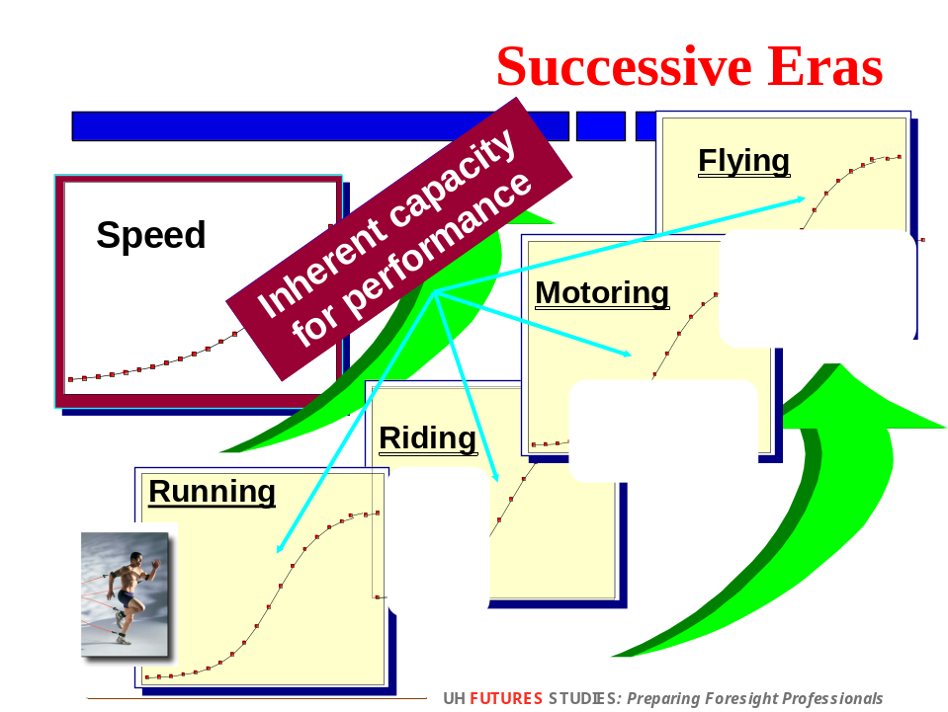

Well that sounds simple enough, but it’s not easy in the least. As we mentioned, the old era is usually quite comfortable to most people; they know how to be successful there. While they admit it’s not perfect, they are afraid of changing it too much. And the process of change is not going to be easy. The new era just doesn’t just pick up where the old era leaves off (Figure 7). Rather there is a short-term decline in performance, a gap, between the mature phase of the old era and the beginning of the new. For instance, if you want a new kitchen or a new road, you have to first tear up the old kitchen or the road before you can build the new one. The same is true for a social system. If one wants a new healthcare or education system, one first has to first dismantle some parts of the old system to make way for the new.

Figure 7 – The Gap between Eras
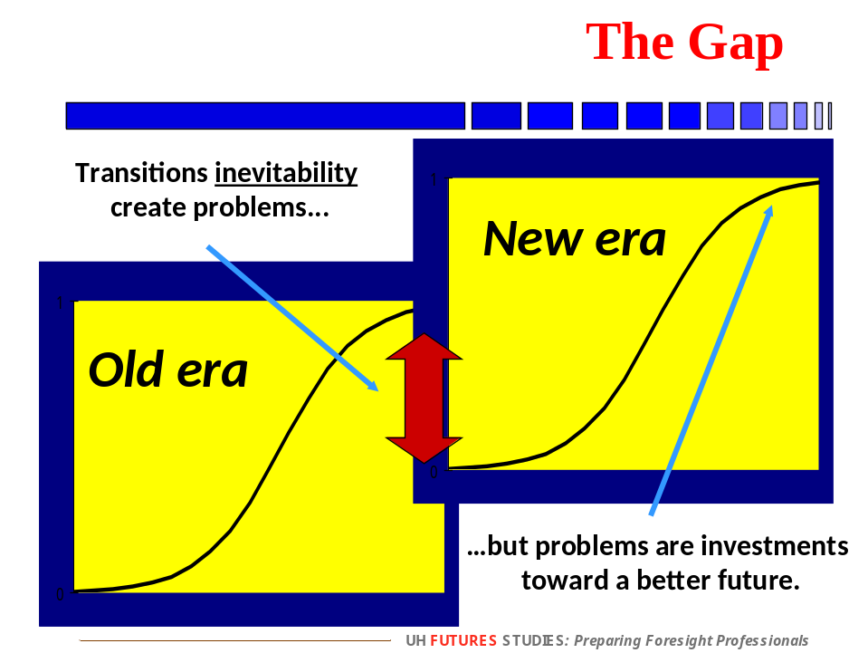

Deciding which parts to dismantle and which parts to keep is not easy. Nor is getting people to give up those parts while trying to maintain enough performance to prevent the system from failing altogether. The new era is new, and learning something new always takes time. The gap always involves costly mistakes and a level of disorganization that most people find quite uncomfortable. And there is no guarantee that abandoning the old era will result in the breakthrough performance promised in the new era anyway. One might destroy something that is OK and not get the glorious future after all. What a bummer!

So people resist discontinuous change for good reason. Nevertheless, changing from one era to another is necessary sooner or later. The only choice is when to make the change. Most people prefer later, hoping in fact that the change will not be necessary at all. But waiting too long can be fatal, too. The longer one waits to leave the old era and begin the new, the more chance there is that the world will come in and say, “Game Over” and shut the system down. That is what happened to the Soviet Union. They waited too long, and the system ultimately collapsed. The Chinese, on the other hand, began changing before the system had become totally useless, a much more successful approach.

The people who promote the transition to the new era are leaders, transformational leaders. They see the need for the new era before others do, and they work to begin the transition to the new era before it is too late.

The model of punctuated equilibrium to describe change also puts the present into the flow of history. Eras did not just happen in the past. The present is also an era, one that had a beginning and certain character, just like all the rest. The difference is that we are not clear on what that character is. Is it the Internet? Terrorism? Globalization? Global warming? Future historians will label this era just as we have labeled the ones before us. And we do not know how this era will end—what discontinuity will close the era, bring its coherence to an end, and open a new one by introducing more unsettling discontinuous changes. No one knows how or when the current era will end. But we can guarantee that it will. The “present” is a temporary condition. Nothing goes on forever. It will end eventually—an unsettling, but profound truth.

While futurists cannot tell when the present era will end, we monitor the global environment for signs of change and imagine how it might. Even if we “get it wrong,” we have still come to terms with the fact that we will have to leave the current era eventually. And we will be more prepared to make the change when it actually comes if we had not mistakenly assumed that the present will go on indefinitely. The longer the current era goes on, the easier it is to confuse it with “reality”—simply the way things are and the way they will always be. Futures studies guards against that misconception. Even “reality” is temporary in the futures perspective!

Resources
Edward Cornish, Futuring: The Exploration of the Future, World Future Society, 2004, chapters 2 and 4.
Cornish founded the World Future Society in 1967 and wrote the first version of this book, The Study of the Future, in 1977. It is the best secondary and undergraduate textbook on futures studies.

Wendell Bell, Foundations of Futures Studies: Human Science for a New Era: History, Purposes, Knowledge, Transaction, 2003.
Bell taught the sociology of the future at Yale for many years. This book is the best graduate and professional introduction to future studies. Bell also wrote a second volume on values in futures work in which he argues that futurists should promote and support universal values for current and future generations.

Draper L. Kauffman, Jr., Teaching the Future: A Guide to Future-oriented Education, ETC, 1976, pp. 59-63.
A great book for futures educators full of instruction and activities.

Thomas Lombardo, Contemporary Futurist Thought, AuthorHouse, 2006, pp 251-281.
An excellent summary of various writers and theories about change.

Eldredge, N., and S. J. Gould. 1972. Punctuated equilibria: an alternative to phyletic gradualism, pp. 82-155. In T. J. Schopf (ed.), Models in Paleobiology. Freeman, Cooper and Co., San Francisco.
http://www.dailymail.co.uk/health/article-1198132/Ethical-storm-flares-British-scientists-create-artificial-sperm-human-stem-cells.html
http://www.merriam-webster.com/dictionary/change
http://www.library.utoronto.ca/utel/ret/cawdrey/cawdrey0.html#work
http://www.historyguide.org/intellect/press.html
The Origin and Development of the Cuneiform System of Writing, Samuel Noah Kramer, Thirty Nine Firsts In Recorded History pp 381-383

